Lab 6: Sequential Circuit Design

**Primary Objectives:**

1. Get experience designing and simulating a simple sequential logic circuit using flip-flops.

**Design**

Table 1: Symbol Mapping

|  |  |
| --- | --- |
| Name | Symbol |
| Input A | A |
| Input B | B |
| Enable | Enable |
| Valid | Valid |
| Direction | Direction |
| Q1 | Q1 |
| D1 | Q1* |
| Q0 | Q0 |
| D0 | Q0* |

Table 1 lists the symbols used in the rest of the document.

Table 2: Truth table for the Spin Direction Detector

|  |  |  |  |  |  |  |  |  |  |  |  |  |  |
| --- | --- | --- | --- | --- | --- | --- | --- | --- | --- | --- | --- | --- | --- |
|  |  |  | Enable A B | | | | | | | |  |  |  |
|  | Q1 | Q0 | 000 | 001 | 010 | 011 | 100 | 101 | 110 | 111 | Valid | Direction |  |
| Default | 0 | 0 | 00 | 00 | 00 | 00 | 01 | 00 | 00 | 00 | 0 | 0 | N/A |
| A&B are 00 | 0 | 1 | 00 | 00 | 00 | 00 | 01 | 11 | 10 | 00 | 0 | 0 | N/A |
| A&B are 10 | 1 | 0 | 00 | 00 | 00 | 00 | 10 | 10 | 10 | 10 | 1 | 1 | Clockwise |
| A&B are 01 | 1 | 1 | 00 | 00 | 00 | 00 | 11 | 11 | 11 | 11 | 1 | 0 | Counter-Clockwise |

Table 2: Truth table for the Spin Direction Detector.

State diagram

K-map simplifications (Enable is always 1 because when enable is 0, all values are 00)

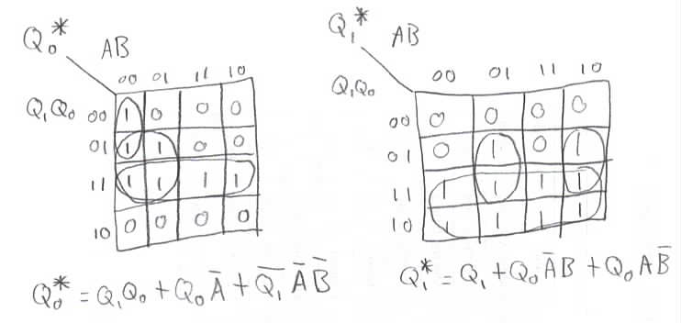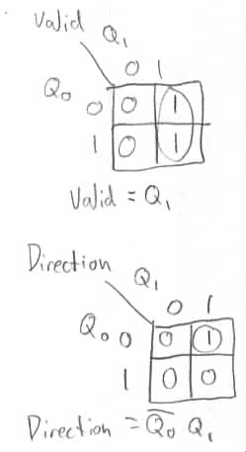

**Implementation**



Implementation of the circuit using Boolean equations from k-map simplification

**Testing**

Log from testing

|  |  |  |  |  |  |  |  |
| --- | --- | --- | --- | --- | --- | --- | --- |
| Enable | A | B | Clock(70,70) | D0 | D1 | Direction | Valid |
| 0 | 0 | 0 | 0 | 0 | 0 | 0 | 0 |
| 0 | 0 | 0 | 1 | 0 | 0 | 0 | 0 |
| 0 | 0 | 0 | 0 | 0 | 0 | 0 | 0 |
| 0 | 1 | 0 | 0 | 0 | 0 | 0 | 0 |
| 0 | 1 | 0 | 1 | 0 | 0 | 0 | 0 |
| 0 | 1 | 0 | 0 | 0 | 0 | 0 | 0 |
| 0 | 0 | 0 | 0 | 0 | 0 | 0 | 0 |
| 0 | 0 | 1 | 0 | 0 | 0 | 0 | 0 |
| 0 | 0 | 1 | 1 | 0 | 0 | 0 | 0 |
| 0 | 0 | 1 | 0 | 0 | 0 | 0 | 0 |
| 1 | 0 | 1 | 0 | 0 | 0 | 0 | 0 |
| 1 | 0 | 1 | 1 | 0 | 0 | 0 | 0 |
| 1 | 0 | 1 | 0 | 0 | 0 | 0 | 0 |
| 1 | 0 | 0 | 0 | 0 | 0 | 0 | 0 |
| 1 | 1 | 0 | 0 | 0 | 0 | 0 | 0 |
| 1 | 1 | 0 | 1 | 0 | 0 | 0 | 0 |
| 1 | 1 | 0 | 0 | 0 | 0 | 0 | 0 |
| 1 | 1 | 1 | 0 | 0 | 0 | 0 | 0 |
| 1 | 1 | 1 | 1 | 0 | 0 | 0 | 0 |
| 1 | 1 | 1 | 0 | 0 | 0 | 0 | 0 |
| 1 | 0 | 1 | 0 | 0 | 0 | 0 | 0 |
| 1 | 0 | 0 | 0 | 0 | 0 | 0 | 0 |
| 1 | 0 | 0 | 1 | 1 | 0 | 0 | 0 |
| 1 | 0 | 0 | 0 | 1 | 0 | 0 | 0 |
| 1 | 0 | 0 | 1 | 1 | 0 | 0 | 0 |
| 1 | 0 | 0 | 0 | 1 | 0 | 0 | 0 |
| 1 | 0 | 1 | 0 | 1 | 0 | 0 | 0 |
| 1 | 0 | 1 | 1 | 1 | 1 | 0 | 1 |
| 1 | 0 | 1 | 0 | 1 | 1 | 0 | 1 |
| 1 | 1 | 1 | 0 | 1 | 1 | 0 | 1 |
| 1 | 1 | 1 | 1 | 1 | 1 | 0 | 1 |
| 1 | 1 | 1 | 0 | 1 | 1 | 0 | 1 |
| 1 | 1 | 0 | 0 | 1 | 1 | 0 | 1 |
| 1 | 1 | 0 | 1 | 1 | 1 | 0 | 1 |
| 1 | 1 | 0 | 0 | 1 | 1 | 0 | 1 |
| 1 | 0 | 0 | 0 | 1 | 1 | 0 | 1 |
| 1 | 0 | 0 | 1 | 1 | 1 | 0 | 1 |
| 1 | 0 | 0 | 0 | 1 | 1 | 0 | 1 |
| 0 | 0 | 0 | 0 | 1 | 1 | 0 | 1 |
| 0 | 0 | 0 | 1 | 0 | 0 | 0 | 0 |
| 0 | 0 | 0 | 0 | 0 | 0 | 0 | 0 |
| 1 | 0 | 0 | 0 | 0 | 0 | 0 | 0 |
| 1 | 0 | 0 | 1 | 1 | 0 | 0 | 0 |
| 1 | 0 | 0 | 0 | 1 | 0 | 0 | 0 |
| 0 | 0 | 0 | 0 | 1 | 0 | 0 | 0 |
| 0 | 0 | 0 | 1 | 0 | 0 | 0 | 0 |
| 0 | 0 | 0 | 0 | 0 | 0 | 0 | 0 |
| 1 | 0 | 0 | 0 | 0 | 0 | 0 | 0 |
| 1 | 0 | 0 | 1 | 1 | 0 | 0 | 0 |
| 1 | 0 | 0 | 0 | 1 | 0 | 0 | 0 |
| 1 | 1 | 0 | 0 | 1 | 0 | 0 | 0 |
| 1 | 1 | 0 | 1 | 0 | 1 | 1 | 1 |
| 1 | 1 | 0 | 0 | 0 | 1 | 1 | 1 |
| 1 | 1 | 1 | 0 | 0 | 1 | 1 | 1 |
| 1 | 1 | 1 | 1 | 0 | 1 | 1 | 1 |
| 1 | 1 | 1 | 0 | 0 | 1 | 1 | 1 |
| 1 | 0 | 1 | 0 | 0 | 1 | 1 | 1 |
| 1 | 0 | 1 | 1 | 0 | 1 | 1 | 1 |
| 1 | 0 | 1 | 0 | 0 | 1 | 1 | 1 |
| 1 | 0 | 0 | 0 | 0 | 1 | 1 | 1 |
| 1 | 0 | 0 | 1 | 0 | 1 | 1 | 1 |
| 1 | 0 | 0 | 0 | 0 | 1 | 1 | 1 |
| 0 | 0 | 0 | 0 | 0 | 1 | 1 | 1 |
| 0 | 0 | 0 | 1 | 0 | 0 | 0 | 0 |
| 0 | 0 | 0 | 0 | 0 | 0 | 0 | 0 |

Functional timing diagram

**Conclusion**

Experience implementing designing and simulating a simple sequential logic circuit using flip-flops has been gained, and the device works as expected.